-----A Line space with Times New Roman 12 font -----

-----A Line space with Times New Roman 12 font -----

**Guide for Authors**

**Title (Comprehensive and informative and must be a maximum of 20 words; Times New Roman Bold, size 13)**

-----A Line space (Times New Roman 12) -----

Author full name1, Author full name2*, Author full name3 (Times New Roman, size 12)

-----A Line space, Times New Roman 10 -----

1. Affiliations, E-mail address (Times New Roman 10)

2. Affiliations, E-mail address ((Times New Roman 10***)***

-----A Line space, (Times New Roman 10) -----

-----A Line space (Times New Roman 10) -----

**Abstract** (Times New Roman, size 12)

The Abstract should be written in Times New Roman font, size 12. The abstract should be typed as a single paragraph and should only be a maximum of 250 words. An abstract should state briefly the research problem, research aims, material and methods, the main findings, and conclusion. Also, non-standard or uncommon abbreviations should be avoided, but if essential they must be defined at their first mention in the abstract itself.

-----A Line space (Times New Roman 12) -----

**Keywords** (Times New Roman, size 12)

Immediately after the abstract, provide three to six keywords that are directly linked to the concept of the paper.

-----A Line space (Times New Roman 12) -----

-----A Line space (Times New Roman 12) -----

**\*Corresponding author's Email:**

-----A Line space (Times New Roman 12) -----

**Title (Times New Roman Bold, size 13)**

-----A Line space (Times New Roman 12) -----

**1. Introduction**

Use 2.5 cm margins from all side of the page. The paper should be prepared as a single column. The paper should be written in Times New Roman 12. Select line spacing 1.15 cm. Main headings should be written in bold font of Times New Roman 12. The article structure includes Introduction, Material and methods, Results and Discussion, and Conclusion.

-----A Line space (Times New Roman 12) -----

1.2. Subdivision - numbered sections

Divide your article into clearly defined and numbered sections. Subsections should be numbered 1.1 (then 1.1.1, 1.1.2...), 1.2, etc. (the abstract is not included in section numbering). Any subsection may be given a brief heading. Each heading should appear on its own separate line.

In introduction, state the objectives of the work and provide an adequate background, avoiding a detailed literature survey or a summary of the results.

-----A Line space (Times New Roman 12) -----

**2. Material and methods**

Provide sufficient details to allow the work to be reproduced by an independent researcher. Methods that are already published should be summarized, and indicated by a reference. If quoting directly from a previously published method, use quotation marks and also cite the source. Any modifications to existing methods should also be described.

-----A Line space (Times New Roman 12) -----

2.1. Formulae

Please submit math equations as editable text and not as images. Present simple formulae in line with normal text where possible and use the solidus (/) instead of a horizontal line for small fractional terms, e.g., X/Y. In principle, variables are to be presented in italics. Powers of e are often more conveniently denoted by exp. Number consecutively any equations that have to be displayed separately from the text (if referred to explicitly in the text). Example, Eq.1:

|  |  |
| --- | --- |
| (1) | $$F=C+T$$ |
| (2) | $$F.f=C.c+T.t$$ |

2.2. Units

Follow internationally accepted rules and conventions: use the international system of units (SI). If other quantities are mentioned, give their equivalent in SI. Each paper should be self-consistent as to symbols and units which should all be properly defined.

-----A Line space (Times New Roman 12) -----

2.3. Tables

Please submit tables as editable text and not as images. Tables can be placed either next to the relevant text in the article. Number tables consecutively in accordance with their appearance in the text and place any table notes below the table body. Be sparing in the use of tables and ensure that the data presented in them do not duplicate results described elsewhere in the article. Please avoid using vertical rules and shading in table cells. Example:

|  |  |  |  |
| --- | --- | --- | --- |
| **Table 1.** Effect of different nutritional diets on length and width (mean±S.E.) of acini of nurse honey bee’s hypopharyngeal glands | | | |
|  | Acinus size (µm) | | |
| Diets | Length |  | Width |
| TA | 154.04±2.11a |  | 94.85±2.06a |
| TB | 143.61±1.65b |  | 87.90±2.19a |
| TC | 121.30±2.02c |  | 68.03±0.79b |
| Control | 90.61±1.82d |  | 64.72±2.05b |
| Means followed by different letters in each column are statistically different (Tukey’s test, *P*˂ 0.05). | | | |

2.4. Figures

Ensure that each figure has a caption. A caption should comprise a brief title (not on the figure itself) and a description of the figure. Keep text in the figures themselves to a minimum but explain all symbols and abbreviations used.



**Figure 1.** Effect of different nutritional diets on the weight (mean ± S.E.) of nurse honey bee’s hypopharyngeal glands. Means marked with the same letters are not statistically different (Tukey’s test, *P*˂ 0.05).

-----A Line space (Times New Roman 12) -----

**3. Results and Discussion**

The Results section should present the findings of the study in the form of text, tables, and figures. The Discussion section should include comparisons with similar studies and provide scientific reasoning behind the observed experimental outcomes.

-----A Line space (Times New Roman 12) -----

**4. Conclusion**

It is mandatory to have a summary and conclusion section after the main text of the manuscript. In this section, a general summary of the findings must be presented.

-----A Line space (Times New Roman 12) -----

**Acknowledgements**

If necessary, appreciate the funders or other persons who contributed in conducting the project (Must be in a maximum of 40 words and written in B Nazanin 12)

-----A Line space (Times New Roman 12) -----

**References**

* References within manuscript:

Depending on the size of the manuscript, a maximum of 10 to 14 sources should be used. References in the text should preferably be applied at the end of the sentence and by providing the reference number in brackets (shift+O and shift+I).

*For example*: '.... as demonstrated [3,6]. Barnaby and Jones [8] obtained a different result ....'

Please ensure that every reference cited in the text is also present in the reference list and vice versa. Unpublished results and personal communications are not recommended in the reference list, but may be mentioned in the text. Indicate references by number(s) in square brackets in line with the text.

* References at the end of manuscript:

All references must follow the Harvard referencing style (available via Google Scholar) and be written in Times New Roman font, size 10. Following figure, illustrates how to retrieve a citation for an article.

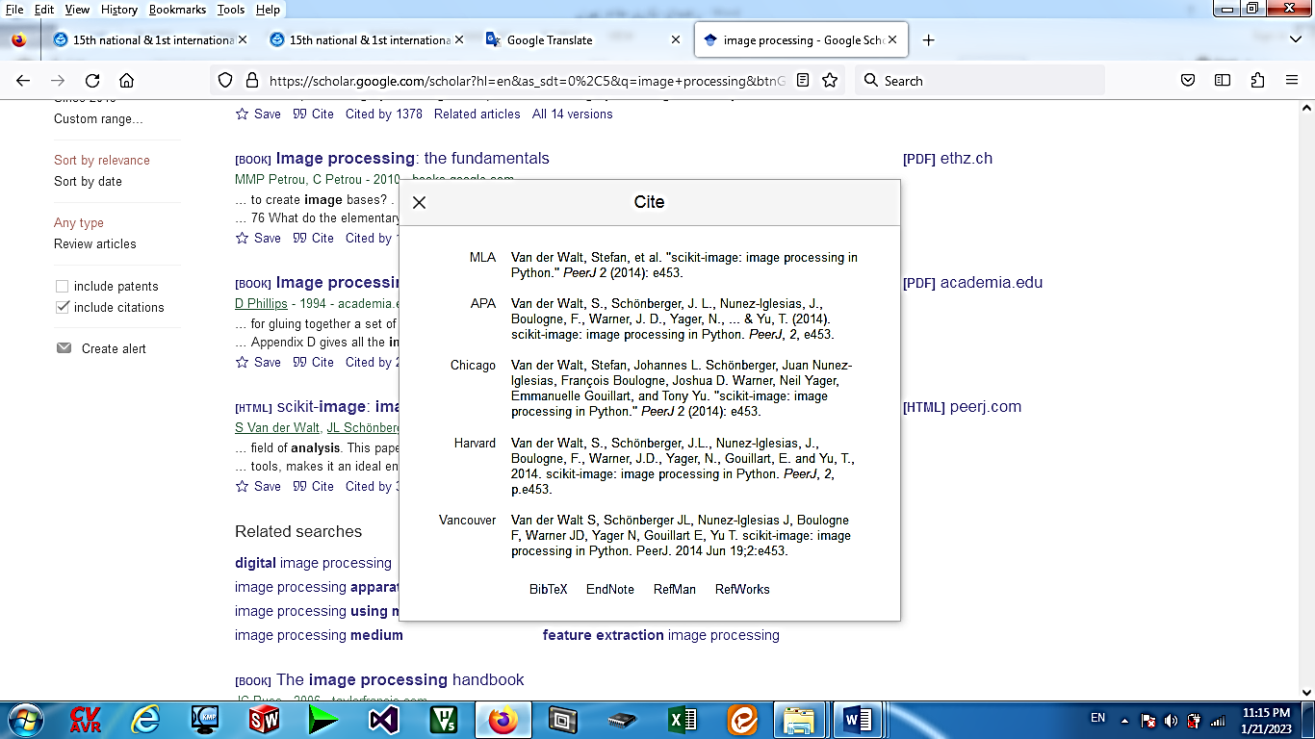

Citations for Persian-language articles must also be provided in English using the Harvard referencing style, with the phrase (In Persian) added at the end.

*A. References to a journal paper:*

Taghizadeh-Tameh, J., Mousazadeh, H., Rafiee, S. and Tarabi, N., 2022. Introducing an innovative magnetic induction tomography system for measuring multiphase flow density. Iranian Journal of Biosystems Engineering, 53(3), 269-288, (In Persian).

Ma, L. and Soleimani, M., 2018. Magnetic induction spectroscopy for permeability imaging. Scientific Reports, 8(1), 1-8.

Moradi, S., Moradi, A., Atabaigi Elmi, V. and Abdollahi, R., 2024. Influence of grain type and fat source on performance, nutrient utilization, and gut properties in broilers fed pelleted diets. Poultry Science, 103, 104093.

Panwar, N.L., Kaushik, S.C. and Kothari, S., 2011. Role of renewable energy sources in environmental protection: A review. Renewable and sustainable energy reviews, 15(3), 1513-1524.

Almomani, F., 2020. Prediction of biogas production from chemically treated co-digested agricultural waste using artificial neural network. Fuel, 280, 118573.

*B. Reference to a book:*

1. Thicket, B., Mitchell, D. and Hallows, B. 1988. Calf Rearing (2nd ed.). United Kingdom: Farming Press Ltd. Pp. 195- 199